<https://www.solvoyo.com/>

<https://www.mckinsey.com/~/media/mckinsey/dotcom/client_service/retail/articles/future_of_retail_supply_chains.pdf>

<https://www.primaseller.com/blog/common-inventory-problems/>

The serious challenges faced by inventory management in absence of technologies like AI and RPA are:

1. Dealing aptly with the dead stock

2. Stock-outs

3. Accelerated storage costs

4. Disorganized order tracking

5. Misplaced inventory stock

6. Diminished customer loyalty

<https://www.economicsdiscussion.net/marketing-2/classification-of-products/31799>

PRODUCTS:

|  |  |  |  |  |
| --- | --- | --- | --- | --- |
| **Marketing consideration** | **Types of Consumer Products** | | | |
| **Convenience** | **Shopping** | **Speciality** | **Unsought** |
| **Customer buying behaviour** | Frequent purchase, little effort (planning, comparison), low customer involvement | Less frequent purchase, much effort (planning and comparison of brands on price, quality, style etc.) | Strong brand preference and loyalty, special purchase effort, little comparison of brands, low price sensitivity | Little product awareness and knowledge or little interest |
| **Price** | Low price | Higher price | High price | Varies |
| **Distribution** | Widespread distribution, convenient locations | Selective distribution, fewer outlets | Exclusive distribution in only one or a few outlets | Varies |
| **Promotion** | Mass promotion | Advertising and personal selling | More carefully targeted promotion | Aggressive advertising and personal selling |
| **Examples** | Toothpaste, magazines, laundry detergent | Television, furniture, clothing | Luxury goods (e.g. Rolex watch), designer clothing | Life insurance or pre-planned funeral service |

CONSUMER PRODUCTS:

I. Convenience products: FMCG,magazines, gift items,drinks, daily or monthly basic needs

ii. Shopping products: electronics , television, air conditioners, cars,household things,clothing furniture, hotel and airline services, tourism services, Furniture, clothing. Readymade Garments, shoes, sarees, major appliances

iii. Speciality products

Architect designed hous An expensive car Special jewelry Planning a wedding Wedding dress Specialist sporting equipment Specialist camping equipment Specialist medical advice Specialist professional advice – legal, financial Home loans for specialist needs Some types of computer software Extensive international holiday

iv. Unsought products.

* Life insurance and funeral insurance Additional warranties on product purchases Encyclopedias Charity donations Some types of exercise equipment Unusual products – perhaps as advertised on the TV shopping channel Sometimes new technology (especially when first introduced to the market) Raffle tickets Fund raising events Sometimes counseling and personal support

**i. Convenience Products:**

Convenience Products are usually low priced, easily available products that customer buys frequently, without any planning or search effort and with minimum comparison and buying effort. Fmcg, ce, wheat flour, salt, sugar, milk and so on.

**ii. Shopping Products:**

Shopping products are high priced (compared to the convenience product), less frequently purchased consumer products and services. the product after a careful consideration of price, quality, features, style and suitability.

**iii. Speciality Products:**

Speciality Products are high priced branded product and services with unique features and the customers are convinced that this product is superior to all other competing brands with regard to its features, quality and hence are willing to pay a high price for the product.

**iv. Unsought Products:**

Unsought product is consumer products that the consumer either does not know about or knows about but does not normally think of buying.

#### **2. Industrial Products:**

ADVERTISEMENTS:

Industrial Products are purchased by business firms for further processing or for use in conducting a business

**Business products include:**

i. Material and parts,

ii. Capital items,

ADVERTISEMENTS:

iii. Supplies, and

iv. Services.

i. Material and parts – Material and parts include raw material like agricultural products, crude petroleum, iron ore, manufactured materials include iron, yarn, cement, wires and component parts include small motors, tires, and castings.

ii. Capital items – Capital items help in production or operation and include installations like factories, offices, fixed equipments like generators, computer systems, elevators and accessory equipments like tools office equipments.

iii. Supplies – Supplies include lubricants, coal, paper, pencils and repair maintenance like paint, nails brooms.

iv. Services – Services include maintenance and repair services like computer repair services, legal services, consultancy services, and advertising services.

* three main types of goods: existing goods, future goods, and contingent goods..
* There are four different types of goods in economics which can be classified based on excludability and rivalrousness: private goods, public goods, common resources, and club goods. Private Goods are products that are excludable and rival. Public goods describe products that are non-excludable and non-rival.
* there are three types of goods in the economic meaning; these are the normal good, inferior goods and luxuary goods. firstly normal goods refers to the increase in the income causes demand for normal goods. and inferior good means that increase in the income causes the decrease in demand for inferior goods.

1. Small sorted less timing and FMCG products: both
2. Medium sorted and information related products to increase consumer demanded products: speed and
3. Large and high priced products that’s need time

## **Online -**

[22% of global retail sales](https://www.statista.com/statistics/534123/e-commerce-share-of-retail-sales-worldwide/) will be thanks to ecommerce by 2023. To give context to this growth, 14.1% of global retail sales were ecommerce purchases in 2019.

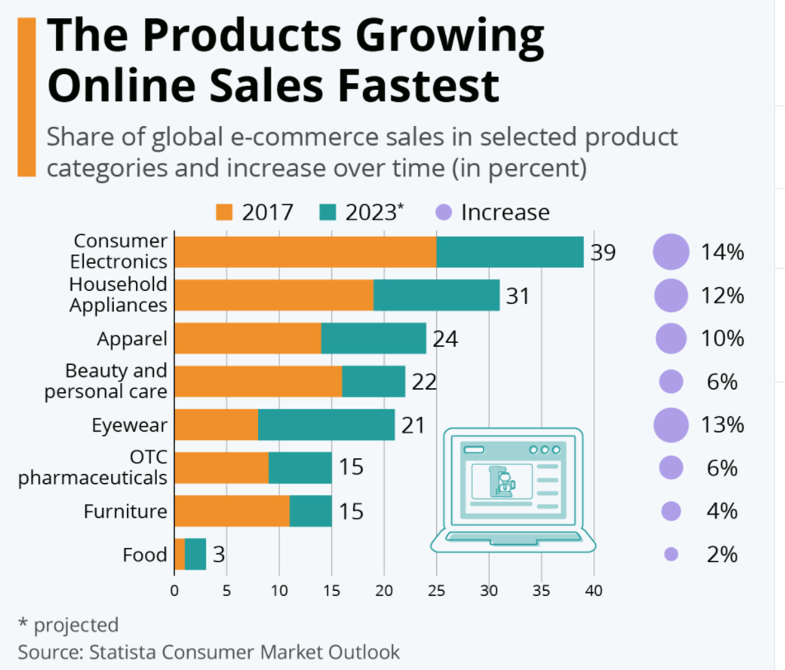

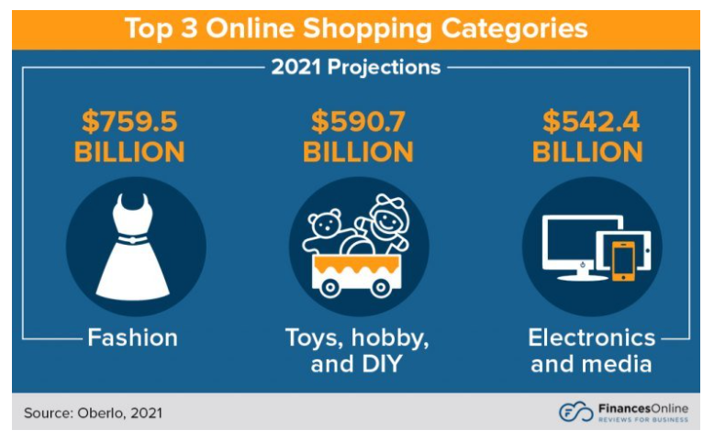

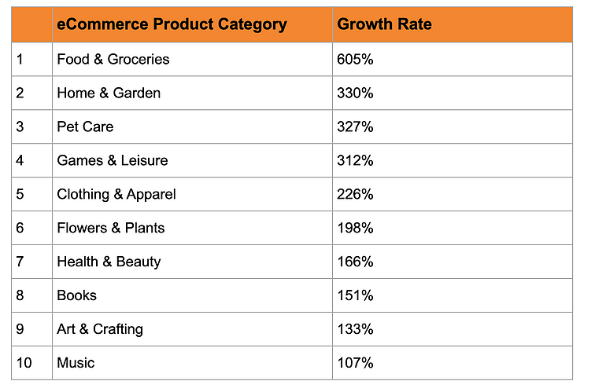

Offline-

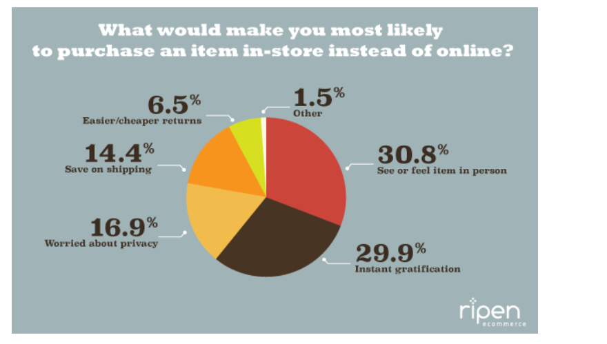

## **The End Goals of AI-Based Product Catalog Management**

The objective of integrating artificial intelligence with retail management is to:

* Optimize product catalogs using demand analysis per item listed, on an ongoing basis
* Automate more workflows like cOptimize product catalogs using demand analysis, etc.
* Speed up time-to-market
* Achieve seamless multi-channel distribution using GTINmatching, ongoing price competitivity checks, etc.

<https://medium.com/@RemiStudios/artificial-intelligence-for-inventory-management-c8a9c0c2a694>

**Demand Prediction for Inventory Management**. This is the simplest approach and, if implemented correctly, can be very informative. As the name suggest, the general idea is to build a time series prediction model that can estimate what demand will be like for the coming days across all items in your inventory. If your company has its own dev team that are familiar with machine learning, we’ve found that some of the highest performing time series methods are currently lstm/rnn models with sliding windows, old school logistic regression with a few tweaks and finally certain probability models, One of the joys of demand prediction is that you can incorporate external data sources into the system to see if they have an impact on demand. We have built systems that ingest the weather data to see if that impacts on prediction — for example we recently undertook a proof of concept for a Fortune 100 company that uncovered a strong causality between temperature above 30 degrees Celsius and part failure. This was done by simply feeding weather data and their inventory data into a single artificial intelligence model and the AI did the rest.

**Reinforcement Learning systems for full-inventory management**. This is the more advanced artificial intelligence approach that involves a model taking serious control of the inventory operations, with human checks and balances. Reinforcement Learning is a domain in artificial intelligence where the models don’t simply make predictions or classifications, but actually act on these predictions. It’s about giving an artificial intelligence the option to act on what it’s predicting. This is done by rewarding and punishing the model for acting incorrectly. In this case, we typically establish punishments for letting an particular inventory item run out of stock, we also punish the model for stock too higher value for too long. For rewards, we primarily focus on ordering items within a safe window before the demand. Reinforcement Systems are hard to implement oneself without prior experience — you need familiarity with simulation models and RL to get anywhere with Inventory. But when done right, they yield phenomenal results. One of our implementations saw a 32% reduction in costs across the operation.

**These models are data hungry.** Unfortunately artificial intelligence systems are extremely data hungry and typically require a few years of inventory data to build a reasonable model. Whenever clients ask us how much data we’d like, we answer ‘everything you can give us’. This can be the biggest problem for Artificial Intelligence implementations at the moment, simply not enough data.

<https://www.thebalancesmb.com/inventory-classification-2221041>

* Fast-moving: items that sell out almost as fast as they're is produced
* High-value: items that sell infrequently
* Hybrid: products that sell moderately quickly

Businesses that carefully classify their warehouse products are better able to efficiently stock inventory.

## Classifying Inventory

.

Here are some general classification rules:

* Group A inventory accounts for about 20% of warehouse items and 80% of dollar usage
* Group B inventory accounts for about 30% of the items and 15% of dollar usage
* Group C inventory accounts for about 50% of the items and 5% of dollar usage

Instead of dollar usage, some companies rely on other criteria, such as transaction usage, unit cost, lead time, and [carrying costs](https://www.thebalancesmb.com/inventory-carrying-costs-2221373).

## Performing an ABC Classification

Many companies perform the ABC classification either by using an enterprise resource planning (ERP) system, a proprietary inventory control system, or by downloading data into an Excel spreadsheet. In any case, after calculations are made, and items are assigned to their relevant groups, logistics departments typically review the results, to make sure they are sound.

As with any calculated value, there may be anomalies that cause items to be improperly sorted. A typically slow-selling item that may experience an unusual spike in sales, could be erroneously assigned to group B, when it should be placed in group C. Logistics departments may subjectively adjust the ABC results, to ensure the most accurate classification possible.

## Counting Inventory

ABC classification is often used [cycle counting](https://www.thebalancesmb.com/cycle-counting-in-the-warehouse-2221188).

## [**https://algopix.com/blog/how-to-improve-your-customer-experience-with-ai-catalog-management**](https://algopix.com/blog/how-to-improve-your-customer-experience-with-ai-catalog-management)

## **The End Goals of AI-Based Product Catalog Management**

The objective of integrating artificial intelligence with retail management is to:

* Optimize product catalogs using demand analysis per item listed, on an ongoing basis
* Automate more workflows like product listing, attribute enhancement, product identifications, etc.
* Speed up time-to-market
* Achieve seamless multi-channel distribution using GTINmatching, ongoing price competitivity checks, etc.

These goals ultimately allow your company to provide better customer experiences, generate more sales with improved margins, and raise customer loyalty.

## **Predictive Inventory Management**

Nothing is more frustrating than attempting to buy something, only to realize that it’s out of stock. Carrying too much stock, at the same time, results in lower profit margins.

How can companies strike a balance between the two? The answer is AI.

AI can help businesses create an optimized product catalog that ensures new products are ordered and available at the right time. AI automatically predicts future demand using data like historical sales, holidays, weather patterns, promotions, and others.

Let’s say you see two products in a specific category trending upwards—similar to the [COVID-19](https://algopix.com/blog/6-post-covid-19-tips-for-online-marketplaces) consumables boom at the start of the pandemic. Predictive inventory management uses AI to analyze product trends in specific categories to forecast inventory levels and ensure a store will have enough inventory to keep up with demand.

## **Targeted Advertisements**

One of the most well-known ways AI helps marketing teams is through targeted promotions and recommendations. Customers like it when businesses can provide relevant offers.

AI algorithms now exist to collect and parse customer data, matching individuals with preferences and price points. The result is a more personalized shopping experience that’s proven to generate more conversions.

Personalization is something that’s taken over all aspects of digital marketing. The largest ecommerce marketplaces use behavioral analytics to serve personalized content. The majority of paid ads on large platforms like Google and Facebook are served to users based on their past search history, cookies, and other tracking data.

Personalization can make all the difference in ecommerce by making relevant suggestions that increase the visibility of specific products. The end result: more conversions. After all, making it easy for customers to find the products they want is the definition of a great customer experience.

## **AI-Driven Shopping Assistants**

AI-driven chatbots and shopping assistants are another example of a low-barrier solutions that is redefining the ecommerce industry.

These AI-powered assistants work in-store too. Macy’s and Lowe’s have “On Call” and “LoweBot” respectively. These programs mimic human interaction, allowing customers to ask questions and receive personalized responses.

Other companies use these chatbots to reach their customers on third-party social media platforms like Facebook’s Messenger. These AI-driven systems ensure that companies can reach their customers on any channel, increasing product visibility and brand awareness.

End main variables for variation of goods and using AI:

1. Fast moving and small sorted product - speed
2. Tangibility of goods

Optimize product catalogs using demand analysis

product listing, attribute enhancement, product identifications

Fast-moving: items that sell out almost as fast as they're is produced High-value: items that sell infrequently

Hybrid: products that sell moderately quickly